EAT Indicator for NT8
For NinjaTrader
Eight AM Trade -- Visual Signal Only
ATM Strategy Setup Guide
v1.0.6 | NinjaTrader 8 | MNQ | Chart Trader

What is an ATM Strategy?
An ATM (Automated Trade Management) Strategy is a saved order template in NinjaTrader's Chart Trader. Every time you click Buy Mkt or Sell Mkt, NinjaTrader places your entry and automatically attaches a Stop and a Target bracket to it on the chart. You then drag those bracket lines to the exact levels EAT Indicator for NT8 has drawn for you.

One-Time Setup: You only need to build this ATM Strategy once. After that it is saved and ready every time you open Chart Trader.

Part 1 -- Building the ATM Strategy

Step 1 -- Open the ATM Dropdown in Chart Trader
In Chart Trader, click the ATM Strategy dropdown. It may show 'None' by default. Select Custom to open the Custom Strategy Parameters dialog.

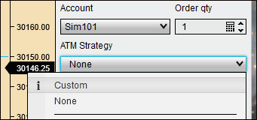
ATM Strategy dropdown -- select Custom

Step 2 -- Fill In the Strategy Parameters
The Custom Strategy Parameters dialog opens. Fill it in exactly as shown below:

Field | Value to Enter
Order quantity | 1
Parameter type | Ticks
Stop loss | 150
Profit target | 200
TIF | GTC
Stop strategy | None

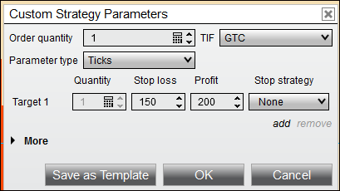
Custom Strategy Parameters -- enter 150 stop and 200 target

Step 3 -- Save as Template
Click Save as Template. A name dialog will appear. Type the name exactly as shown, then click Save:

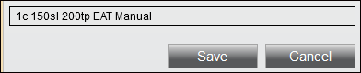
Name the template: 1c 150sl 200tp EAT Indicator for NT8

Tip: Use this exact name so it is easy to find in the dropdown before each trade.

Step 4 -- Select Your New ATM Strategy
Click the ATM Strategy dropdown and choose the ATM you just saved. When selected, it should look like this:

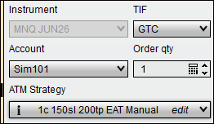
ATM Strategy selected and ready in Chart Trader

Part 2 -- Setting Chart Trader Properties

Step 5 -- Open Chart Trader Properties
This is the most important setup step. You need to change one setting so that every time you click Buy Mkt or Sell Mkt, NinjaTrader places a separate Stop flag and Target flag on the chart for each contract -- allowing you to move each one independently to the EAT Indicator for NT8 levels.

Right-click in the area highlighted by the green circle in Chart Trader, then choose Properties:

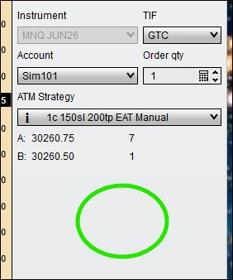
Right-click in the Chart Trader panel area to open Properties

Step 6 -- Set ATM Strategy Selection Mode
In the Properties dialog, under the General section, find ATM strategy selection mode. Open the dropdown and choose Keep selected ATM strategy template on order submission:

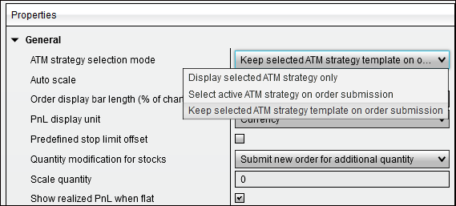
Select: Keep selected ATM strategy template on order submission

Why This Matters: This is the key setting. With this mode active, each time you click Buy Mkt or Sell Mkt it places one contract with its own independent Stop and Target flags on the chart. You can then drag each flag to any price level you choose.

Step 7 -- Customize Colors (Optional)
While you are in the Properties tab, you can customize the colors of the action buttons and order lines to suit your preference. The screenshot below shows the color scheme used in this guide as a reference -- choose whatever works best for you and save your preset.

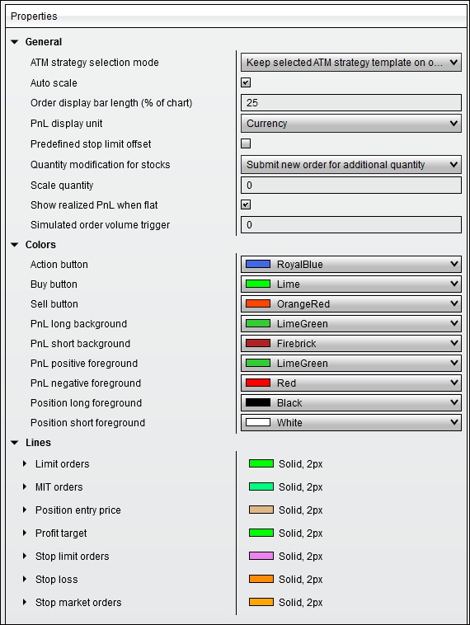
Chart Trader Properties -- color customization (optional)

How to Use the ATM in a Live Trade
Once your ATM is set up, using it is straightforward:

Step | Action
1 | Confirm your ATM Strategy dropdown shows: 1c 150sl 200tp EAT Indicator for NT8
2 | When EAT Indicator for NT8 signals, click Buy Mkt (for a LONG) or Sell Mkt (for a SHORT).
3 | NinjaTrader fills your order and immediately places a red Stop flag and green Target flag on the chart.
4 | Drag the red Stop flag to the EAT Indicator for NT8 red dashed Stop line on the chart.
5 | Drag the green Target flag to your chosen EAT Indicator for NT8 level (lime = TP1, cyan = TP2, blue = Runner).
6 | To add a runner: click Buy Mkt or Sell Mkt again for a second contract. Drag that Target flag to the blue Runner line.
7 | As price hits your first target, trail the runner Stop flag behind price to lock in gains.

Note: Each click of Buy Mkt or Sell Mkt places one bracket of 1 contract with its own independent Stop and Target. You manage each bracket separately on the chart.

